# Mapping Federal Agencies to State Agencies in OR, WA, CA and TX.

We chose these states as the majority of OSU students are from those areas.

# Career with state agencies – OR, TX, WA, CA

## Federal Agencies – Agencies in the State of Oregon

|  |  |  |
| --- | --- | --- |
| Category | Federal Agencies | Oregon State Agencies |
| Public Health and Human Services | [Department of Health and Human Services (HHS)](https://www.hhs.gov/), [Centers for Disease Control and Prevention (CDC)](https://www.cdc.gov/), [National Institutes of Health (NIH)](https://www.nih.gov/), [Food and Drug Administration (FDA)](https://www.fda.gov/), [Substance Abuse and Mental Health Services Administration (SAMHSA)](https://www.samhsa.gov/), [Social Security Administration (SSA)](https://www.ssa.gov/) | [Oregon Health Authority (OHA)](https://www.oregon.gov/oha), [Oregon Department of Human Services (ODHS)](https://www.oregon.gov/dhs), [Oregon State Hospital (OSH)](https://www.oregon.gov/oha/osh) |
| Environmental Protection and Natural Resources | [Environmental Protection Agency (EPA)](https://www.epa.gov/), [Department of the Interior (DOI)](https://www.doi.gov/) ([Bureau of Land Management (BLM)](https://www.blm.gov/), [National Park Service (NPS)](https://www.nps.gov/), [Fish and Wildlife Service (FWS)](https://www.fws.gov/)), [U.S. Department of Agriculture (USDA)](https://www.usda.gov/) ([U.S. Forest Service (USFS)](https://www.fs.usda.gov/)), [National Oceanic and Atmospheric Administration (NOAA)](https://www.noaa.gov/) | [Department of Environmental Quality (DEQ)](https://www.oregon.gov/deq), [Oregon Department of Fish and Wildlife (ODFW)](https://www.dfw.state.or.us/), [Oregon Water Resources Department (OWRD)](https://www.oregon.gov/owrd), [Oregon State Parks](https://stateparks.oregon.gov/) |
| Transportation and Infrastructure | [Department of Transportation (DOT)](https://www.transportation.gov/), [Federal Aviation Administration (FAA)](https://www.faa.gov/), [Federal Highway Administration (FHWA)](https://www.fhwa.dot.gov/), [Federal Railroad Administration (FRA)](https://railroads.dot.gov/), [U.S. Army Corps of Engineers](https://www.usace.army.mil/) | [Oregon Department of Transportation (ODOT)](https://www.oregon.gov/odot), [Driver and Motor Vehicle Services Division (DMV)](https://www.oregon.gov/ODOT/DMV), [Oregon Aviation Board](https://www.oregon.gov/aviation/Pages/default.aspx) |
| Education and Workforce Development | [Department of Education (ED)](https://www.ed.gov/), [Department of Labor (DOL)](https://www.dol.gov/), [Employment and Training Administration (ETA)](https://www.dol.gov/agencies/eta) | [Oregon Department of Education (ODE)](https://www.oregon.gov/ode), [Higher Education Coordinating Commission (HECC)](https://www.oregon.gov/highered), [Oregon Employment Department (OED)](https://www.oregon.gov/employ) |
| Public Safety and Law Enforcement | [Department of Justice (DOJ)](https://www.justice.gov/) ([Federal Bureau of Investigation (FBI)](https://www.fbi.gov/), [Drug Enforcement Administration (DEA)](https://www.dea.gov/), [Bureau of Alcohol, Tobacco, Firearms and Explosives (ATF)](https://www.atf.gov/)), [Department of Homeland Security (DHS)](https://www.dhs.gov/) ([Federal Emergency Management Agency (FEMA)](https://www.fema.gov/), [Transportation Security Administration (TSA)](https://www.tsa.gov/)), [U.S. Marshals Service](https://www.usmarshals.gov/) | [Oregon State Police (OSP)](https://www.oregon.gov/osp), [Oregon Department of Justice (ODOJ)](https://www.doj.state.or.us/), [Oregon Emergency Management (OEM)](https://www.oregon.gov/OEM) |
| Economic Development and Finance | [Department of the Treasury](https://home.treasury.gov/) ([Internal Revenue Service (IRS)](https://www.irs.gov/), [Office of the Comptroller of the Currency (OCC)](https://www.occ.treas.gov/)), [Department of Commerce](https://www.commerce.gov/) ([U.S. Census Bureau](https://www.census.gov/), [Small Business Administration (SBA)](https://www.sba.gov/), [Economic Development Administration (EDA)](https://www.eda.gov/)) | [Oregon Department of Revenue (DOR)](https://www.oregon.gov/DOR), [Business Oregon](https://www.oregon.gov/biz), [Oregon Lottery](https://www.oregonlottery.org/), [Oregon State Treasury](https://www.oregon.gov/treasury) |
| Housing and Urban Development | [Department of Housing and Urban Development (HUD)](https://www.hud.gov/) ([Federal Housing Administration (FHA)](https://www.hud.gov/program_offices/housing)), [USDA Rural Housing Service](https://www.rd.usda.gov/) | [Oregon Housing and Community Services (OHCS)](https://www.oregon.gov/ohcs), [Land Conservation and Development Commission (LCDC)](https://www.oregon.gov/LCD) |
| Agriculture and Food | [U.S. Department of Agriculture (USDA)](https://www.usda.gov/) ([Food Safety and Inspection Service (FSIS)](https://www.fsis.usda.gov/), [Animal and Plant Health Inspection Service (APHIS)](https://www.aphis.usda.gov/)) | [Oregon Department of Agriculture (ODA)](https://www.oregon.gov/ODA) |
| Energy and Utilities | [Department of Energy (DOE)](https://www.energy.gov/), [Federal Energy Regulatory Commission (FERC)](https://www.ferc.gov/), [Nuclear Regulatory Commission (NRC)](https://www.nrc.gov/) | [Oregon Department of Energy (ODOE)](https://www.oregon.gov/energy), [Public Utility Commission of Oregon (PUC)](https://www.oregon.gov/puc) |
| Veterans Affairs and Military | [Department of Veterans Affairs (VA)](https://www.va.gov/), [Department of Defense (DOD)](https://www.defense.gov/) | [Oregon Department of Veterans’ Affairs (ODVA)](https://www.oregon.gov/odva), [Oregon Military Department (OMD)](https://www.oregon.gov/omd) |
| Cultural, Historical, and Arts | [National Endowment for the Arts (NEA)](https://www.arts.gov/), [National Endowment for the Humanities (NEH)](https://www.neh.gov/), [Smithsonian Institution](https://www.si.edu/) | [Oregon Arts Commission](https://www.oregonartscommission.org/), [Oregon Heritage Commission](https://www.oregon.gov/oprd/OH/pages/default.aspx), [State Historic Preservation Office (SHPO)](https://www.oregon.gov/oprd/OH/pages/shpo.aspx) |

## Federal Agencies – Agencies in the State of Texas

|  |  |  |
| --- | --- | --- |
| **Function** | **Federal Agencies** | **Texas State Agencies** |
| **Agriculture** | [U.S. Department of Agriculture (USDA)](https://www.usda.gov/) | [Texas Department of Agriculture (TDA)](https://www.texasagriculture.gov/) |
| **Business & Economic Development** | [Department of Commerce](https://www.commerce.gov/) [Small Business Administration (SBA)](https://www.sba.gov/) | [Texas Economic Development Corporation](https://businessintexas.com/) |
| **Defense & National Security** | [Department of Defense (DoD)](https://www.defense.gov/) [Department of Homeland Security (DHS)](https://www.dhs.gov/) | [Texas Military Department (TMD)](https://tmd.texas.gov/) |
| **Criminal Justice & Public Safety** | [Department of Justice (DOJ)](https://www.justice.gov/) [Federal Bureau of Investigation (FBI)](https://www.fbi.gov/) | [Texas Department of Public Safety (DPS)](https://www.dps.texas.gov/) [Texas Department of Criminal Justice (TDCJ)](https://www.tdcj.texas.gov/) |
| **Education** | [Department of Education (ED)](https://www.ed.gov/) | [Texas Education Agency (TEA)](https://tea.texas.gov/) |
| **Energy** | [Department of Energy (DOE)](https://www.energy.gov/) | [Railroad Commission of Texas](https://www.rrc.texas.gov/) (Oil & Gas) |
| **Environmental Protection** | [Environmental Protection Agency (EPA)](https://www.epa.gov/) | [Texas Commission on Environmental Quality (TCEQ)](https://www.tceq.texas.gov/) |
| **Health & Human Services** | [Department of Health and Human Services (HHS)](https://www.hhs.gov/) [Centers for Disease Control and Prevention (CDC)](https://www.cdc.gov/) | [Texas Health and Human Services Commission (HHSC)](https://www.hhs.texas.gov/) |
| **Housing & Community Development** | [Department of Housing and Urban Development (HUD)](https://www.hud.gov/) | [Texas Department of Housing and Community Affairs (TDHCA)](https://www.tdhca.state.tx.us/) |
| **Insurance Regulation** | [Federal Insurance Office (FIO)](https://home.treasury.gov/policy-issues/financial-markets-financial-institutions-and-fiscal-service/federal-insurance-office) | [Texas Department of Insurance (TDI)](https://www.tdi.texas.gov/) |
| **Labor & Employment** | [Department of Labor (DOL)](https://www.dol.gov/) | [Texas Workforce Commission (TWC)](https://www.twc.texas.gov/) |
| **Law Enforcement & Corrections** | [Federal Bureau of Prisons (BOP)](https://www.bop.gov/) | [Texas Department of Criminal Justice (TDCJ)](https://www.tdcj.texas.gov/) |
| **Transportation** | [Department of Transportation (DOT)](https://www.transportation.gov/) | [Texas Department of Transportation (TxDOT)](https://www.txdot.gov/) |
| **Veterans Affairs** | [Department of Veterans Affairs (VA)](https://www.va.gov/) | [Texas Veterans Commission (TVC)](https://www.tvc.texas.gov/) |

## Federal Agencies – Agencies in the State of Washington

|  |  |  |
| --- | --- | --- |
| **Function** | **Federal Agencies (**[**USA.gov**](https://www.usa.gov/branches-of-government)**)** | **Washington State Agencies (**[**WA.gov**](https://wa.gov/agency)**)** |
| **Law Enforcement & Public Safety** | [Federal Bureau of Investigation (FBI)](https://www.fbi.gov/), [Bureau of Alcohol, Tobacco, Firearms and Explosives (ATF)](https://www.atf.gov/), [Drug Enforcement Administration (DEA)](https://www.dea.gov/), [United States Marshals Service (USMS)](https://www.usmarshals.gov/), [Department of Homeland Security (DHS)](https://www.dhs.gov/), [Federal Bureau of Prisons (BOP)](https://www.bop.gov/) | [Washington State Patrol (WSP)](https://www.wsp.wa.gov/), [Department of Corrections (DOC)](https://www.doc.wa.gov/), [Washington Association of Sheriffs & Police Chiefs (WASPC)](https://www.waspc.org/), [Washington Military Department (MIL)](https://mil.wa.gov/) |
| **Taxation & Revenue** | [Internal Revenue Service (IRS)](https://www.irs.gov/), [Department of the Treasury (DOF)](https://home.treasury.gov/) | [Department of Revenue (DOR)](https://dor.wa.gov/), [Washington State Lottery (LOT)](https://www.walottery.com/) |
| **Environmental Protection** | [Environmental Protection Agency (EPA)](https://www.epa.gov/), [Department of the Interior (DOI)](https://www.doi.gov/), [United States Forest Service (USFS)](https://www.fs.usda.gov/), [National Oceanic and Atmospheric Administration (NOAA)](https://www.noaa.gov/), [United States Fish and Wildlife Service (FWS)](https://www.fws.gov/) | [Department of Ecology (DOE)](https://ecology.wa.gov/), [Department of Natural Resources (DNR)](https://www.dnr.wa.gov/), [Washington Department of Fish and Wildlife (WDFW)](https://wdfw.wa.gov/), [Washington State Parks and Recreation Commission (Parks)](https://parks.wa.gov/) |
| **Transportation & Infrastructure** | [Department of Transportation (DOT)](https://www.transportation.gov/), [Federal Aviation Administration (FAA)](https://www.faa.gov/), [Federal Highway Administration (FHWA)](https://www.fhwa.dot.gov/), [National Railroad Passenger Corporation (Amtrak)](https://www.amtrak.com/) | [Washington State Department of Transportation (WSDOT)](https://wsdot.wa.gov/), [Washington State Ferries (WSF)](https://wsdot.wa.gov/travel/washington-state-ferries), [Utilities and Transportation Commission (UTC)](https://utc.wa.gov/) |
| **Health & Human Services** | [Department of Health and Human Services (HHS)](https://www.hhs.gov/), [Centers for Disease Control and Prevention (CDC)](https://www.cdc.gov/), [National Institutes of Health (NIH)](https://www.nih.gov/), [Food and Drug Administration (FDA)](https://www.fda.gov/) | [Department of Health (DOH)](https://doh.wa.gov/), [Health Care Authority (HCA)](https://www.hca.wa.gov/), [Department of Social and Health Services (DSHS)](https://www.dshs.wa.gov/) |
| **Employment & Labor** | [Department of Labor (DOL)](https://www.dol.gov/), [Occupational Safety and Health Administration (OSHA)](https://www.osha.gov/), [Equal Employment Opportunity Commission (EEOC)](https://www.eeoc.gov/) | [Employment Security Department (ESD)](https://esd.wa.gov/), [Department of Labor and Industries (L&I)](https://www.lni.wa.gov/) |
| **Education & Research** | [Department of Education (DOE)](https://www.ed.gov/), [National Science Foundation (NSF)](https://www.nsf.gov/) | [Office of Superintendent of Public Instruction (OSPI)](https://www.k12.wa.us/), [State Board for Community and Technical Colleges (SBCTC)](https://www.sbctc.edu/) |
| **Corrections & Justice** | [Department of Justice (DOJ)](https://www.justice.gov/), [Federal Bureau of Prisons (BOP)](https://www.bop.gov/) | [Department of Corrections (DOC)](https://www.doc.wa.gov/), [Office of Civil Legal Aid (OCLA)](https://ocla.wa.gov/) |
| **Economic Development** | [Small Business Administration (SBA)](https://www.sba.gov/), [Department of Commerce (DOC)](https://www.commerce.gov/) | [Washington State Department of Commerce (Commerce)](https://www.commerce.wa.gov/), [Washington State Liquor and Cannabis Board (WSLCB)](https://lcb.wa.gov/) |
| **Housing & Urban Development** | [Department of Housing and Urban Development (HUD)](https://www.hud.gov/) | [Washington State Housing Finance Commission (WSHFC)](https://www.wshfc.org/) |
| **Agriculture & Food Regulation** | [United States Department of Agriculture (USDA)](https://www.usda.gov/), [Food and Drug Administration (FDA)](https://www.fda.gov/) | [Washington State Department of Agriculture (WSDA)](https://agr.wa.gov/) |
| **Military & Veterans Affairs** | [Department of Defense (DOD)](https://www.defense.gov/), [Department of Veterans Affairs (VA)](https://www.va.gov/) | [Washington Department of Veterans Affairs (WDVA)](https://www.dva.wa.gov/), [Washington Military Department (MIL)](https://mil.wa.gov/) |

## Federal Agencies – Agencies in the State of California

|  |  |  |
| --- | --- | --- |
| **Function** | **Federal Agencies** | **California State Agencies** |
| **Executive Leadership** | [Office of Management and Budget](https://www.whitehouse.gov/omb/), [Department of State](https://www.state.gov/) | [Governor's Office](https://www.ca.gov/agency/?item=governors-office), [Department of Finance](https://www.dof.ca.gov/) |
| **Public Safety & Law Enforcement** | [Department of Justice](https://www.justice.gov/), [Homeland Security](https://www.dhs.gov/) | [California DOJ](https://oag.ca.gov/), [Highway Patrol](https://www.chp.ca.gov/) |
| **Health & Human Services** | [Health and Human Services](https://www.hhs.gov/), [Centers for Medicare & Medicaid](https://www.cms.gov/) | [California Health & Human Services](https://www.chhs.ca.gov/), [Public Health](https://www.cdph.ca.gov/) |
| **Environment & Natural Resources** | [EPA](https://www.epa.gov/), [Interior](https://www.doi.gov/) | [California Environmental Protection](https://calepa.ca.gov/), [Fish and Wildlife](https://wildlife.ca.gov/) |
| **Transportation** | [Department of Transportation](https://www.transportation.gov/) | [California DOT](https://dot.ca.gov/) |
| **Education** | [Department of Education](https://www.ed.gov/) | [California Department of Education](https://www.cde.ca.gov/) |
| **Labor & Employment** | [Department of Labor](https://www.dol.gov/) | [Labor and Workforce Development](https://www.labor.ca.gov/), [Employment Development](https://edd.ca.gov/) |
| **Economic Development** | [Department of Commerce](https://www.commerce.gov/), [Small Business Administration](https://www.sba.gov/) | [Business Oversight](https://dbo.ca.gov/), [Business & Economic Development](https://business.ca.gov/) |
| **Defense & Military** | [Department of Defense](https://www.defense.gov/) | [California Military Department](https://calguard.ca.gov/) |
| **Agriculture & Rural Development** | [US Department of Agriculture](https://www.usda.gov/) | [California Department of Food & Agriculture](https://www.cdfa.ca.gov/) |
| **Housing & Urban Development** | [Housing & Urban Development](https://www.hud.gov/) | [Housing and Community Development](https://www.hcd.ca.gov/) |
| **Energy** | [Department of Energy](https://www.energy.gov/) | [California Energy Commission](https://www.energy.ca.gov/) |

# Careers with counties in Oregon

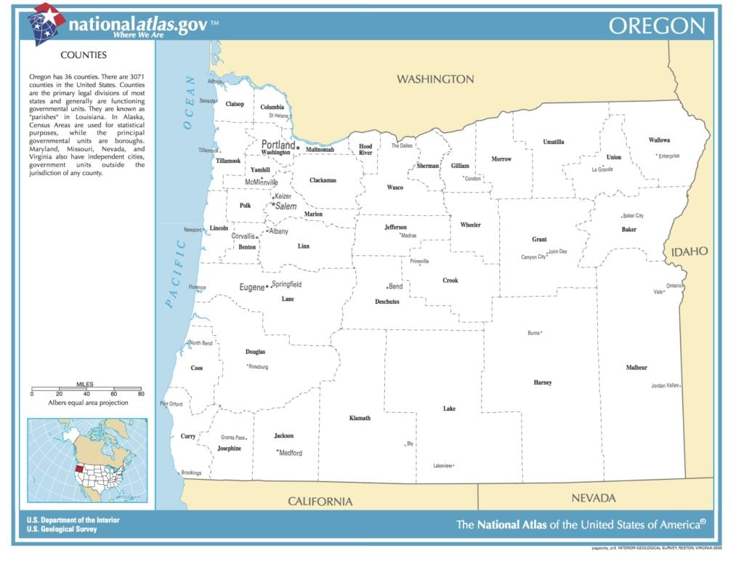

|  |  |
| --- | --- |
| **County** | **Job Listings URL** |
| Baker | <https://www1.bakercounty.org/JobPostings.nsf/xView.xsp> |
| Benton | <https://www.governmentjobs.com/careers/bentonor> |
| Clackamas | <https://hrapp.clackamas.us/psc/recruit/EMPLOYEE/HRMS/c/HRS_HRAM_FL.HRS_CG_SEARCH_FL.GBL?Page=HRS_APP_SCHJOB_FL&Action=U> |
| Clatsop | <https://jobs.dayforcehcm.com/en-US/clatsopcounty/CANDIDATEPORTAL> |
| Columbia | <https://columbiaor.casellehire.com/jobs/> |
| Coos | <https://www.co.coos.or.us/jobs> |
| Crook | <https://crook-county.hiringthing.com/> |
| Curry | <https://www.currycountyor.gov/jobs_and_rfp_s/index.php> |
| Deschutes | <https://www.governmentjobs.com/careers/deschutes> |
| Douglas | <https://www.governmentjobs.com/careers/douglasor> |
| Gilliam | <https://www2.appone.com/Search/Search.aspx?ServerVar=morrowcounty.appone.com> |
| Grant | <https://grantcountyoregon.net/Jobs.aspx> |
| Harney | <https://harneycountyor.gov/job-openings-bid-opportunities/> |
| Hood River | <https://www.hoodrivercounty.gov/county-jobs> |
| Jackson | <https://www.governmentjobs.com/careers/jacksoncountyor?sort=PostingDate%7CDescending> |
| Jefferson | <https://www.governmentjobs.com/careers/jeffersonor> |
| Josephine | <https://www.governmentjobs.com/careers/josephine> |
| Klamath | <https://klamathcounty.applytojob.com/apply> |
| Lake | <https://lakecountyor.org/employment/index.php> |
| Lane | <https://www.governmentjobs.com/careers/lanecountyor> |
| Lincoln | <https://www.governmentjobs.com/careers/lincoln?page=1> |
| Linn | <https://www.linncountyor.gov/jobs> |
| Malheur | <https://www.governmentjobs.com/careers/malheurco> |
| Marion | <https://www.governmentjobs.com/careers/marion> |
| Morrow | <https://www2.appone.com/Search/Search.aspx?ServerVar=morrowcounty.appone.com> |
| Multnomah | <https://multco.wd1.myworkdayjobs.com/Multco_Jobs> |
| Polk | <https://www.governmentjobs.com/careers/polkcoor> |
| Sherman | <https://www.co.sherman.or.us/jobs> |
| Tillamook | <https://www.governmentjobs.com/careers/tillamookor> |
| Umatilla | <https://umatilla.casellehire.com/jobs/> |
| Union | <https://unioncountyor.gov/administrative-services/employment/> |
| Wallowa | <https://www.co.wallowa.or.us/jobs> |
| Wasco | <https://www.co.wasco.or.us/departments/human_resources/employment.php> |
| Washington | <https://www.governmentjobs.com/careers/cowashingtonor> |
| Wheeler | <https://www.wheelercountyoregon.com/> |
| Yamhill | <https://www.governmentjobs.com/careers/yamhillor> |